**Outliers:**What are outliers Here and how they handled?  
In Test data, if certain word appears that seen in Train data and there can few words which didn’t seen in train data, they’re called outliers and it’s handled by Laplace Smoothing.  
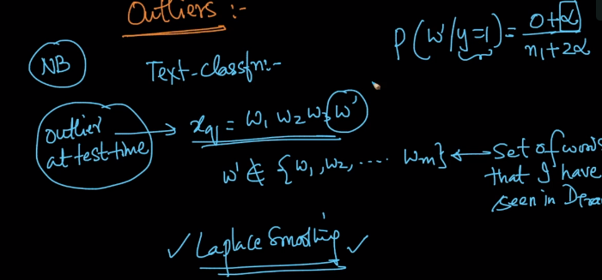  
In train data, if a word appears very few times in both class labels, then it is considered as an outlier. They can be handled in two ways,   
1) we can set a variable limit, if word appear less than that, ignore that word  
for example E=10, if any word appears less than 10, then do not include t in words.  
2) Use Laplace Smoothing with reasonable value of alpha  
